
Vol 14, Issue 1, (2025) E-ISSN: 2226-3624

ChatGPT Embryonic Stages in STEM Subject from Reflective Strategy Based Assessment

Rosidah Md Desa¹, Mohd Effendi Ewan Mohd Matore^{2*}
¹Faculty of Education, Universiti Kebangsaan Malaysia, UKM Bangi, Selangor, Malaysia, ²Research Centre of Education Leadership and Policy, Faculty of Education, Universiti Kebangsaan Malaysia, UKM Bangi, Selangor, Malaysia
Corresponding Author Email: effendi@ukm.edu.my
To Link this Article: http://dx.doi.org/10.6007/IJAREMS/v14-i1/24505 DOI:10.6007/IJAREMS/v14-i1/24505
Published Online: 27 January 2025

Abstract
ChatGPT applications in STEM subjects (Science, Technology, Engineering, Mathematics) has a place in the teaching and learning phase of students. ChatGPT is important for students, because it is very helpful to publish ideas and explicitly analyze an idea. STEM learning with ChatGPT will support better self-learning with the help of teachers. The discussion of ChatGPT in STEM using the SCORE model is not much discussed compared to the model in other strategy planning tools. Therefore, this concept paper aims to describe strategy-based assessment in ChatGPT in STEM practice in Malaysia using the SCORE Model. The methodology used for this concept paper is the thorough analysis of ChatGPT in STEM using SCORE model that measured among five elements such as Strengths (S), Challenges (C), Options (O), Responses (R) and Effectiveness (E). The major findings show that SCORE model effectively can show the potential of ChatGPT in STEM by recognizing the strength, challenges, options, responses and effectiveness in educational context. This encourages students to use technology medium in helping them generate idea systematically. These qualities are supporting the ability of students to choose the right information in solving STEM problems. The limitation on this paper can be improving by using any other model to get variety of perspectives such as SWOT, TOWS, NOISE, and SOAR. This finding has important implications towards the better understanding of the student’s community using ChatGPT in STEM ethically and see the future potential. Further research might include the possibility of doing research on the qualitative parts in exploring more on the factors that can threaten the ChatGPT in STEM, especially for those students with low ability in technology.
Keywords: ChatGPT, STEM; SCORE Model, Planning Tool, Strategy, Decision Making

Introduction
ChatGPT is one type of artificial intelligence or better known as Artificial Intelligence (AI). ChatGPT was developed by the company Open AI and on November 30, 2022 the company officially launched to the public Chat Generative Pre-Trained Transformer or ChatGPT for short (Al-Abdullatif & Alsubaie, 2024). In terms, Chat means conversation or chat while GPT is an acronym for (Generative Pre-Training Transformer) which is a machine learning model or system that uses deep learning methods to generate text in the virtual world (online) just like human thought in real time. At the formal level, recommendations have been developed for higher education institutions with basic guidelines on the use of ChatGPT in higher education and its application in teaching and learning, administration, and community involvement (Madunić & Sovulj, 2024).

This ChatGPT has a main advantage that helps in the field of education, which is like speeding up the process of gathering ideas. ChatGPT is able to collect a lot of text at once and provide a summary of the content. This can speed up the process of gathering ideas for a question or project. In addition, ChatGPT is able to generate text and can be used to generate text (response) just like humans. This makes it a useful chatbox for creating chatbots for purposes such as customer service, answering questions in online forums or creating content or social content for social media posts. Many industries use ChatGPT such as the marketing field (production of product or service content and market research, in addition to trend analysis), the health field (helping to identify diseases and drug description matters) as well as the education field (helping to launch learning methods and speed up the learning process). Conceptualizing ChatGPT literacy and charting its key components are essential to ensure appropriate ethical use, maintain academic integrity, and enhance the quality of language education in the AI era (Ma et al., 2024).

When talking about today's education gateway, STEM is important as a preparation for students to face challenges and be competitive at the global level. Most developed countries emphasize STEM because it covers every aspect of society's life and contributes to future economic progress. Science, Technology, Engineering and Mathematics (STEM) education is important in national development thus helping to ensure Malaysia becomes a developed country. The Malaysian Ministry of Education Annual Report 2020 states that a total of 47 percent of university students in Malaysia take STEM subjects, and 20 percent of them take Pure Science STEM subjects, while the rest are in Technical and Vocational Education and Training (TVET).

The main reason we need STEM graduates in the future is to help find solutions to various global problems - whether it's climate change, disease, or cybercrime. STEM subjects also equip students with critical thinking skills, problem solving skills, and exploratory learning skills that prepare them for successful careers and help support the nation's economic development. Sadly, there is also not much research on STEM ways of thinking, with even fewer theoretical perspectives and frameworks on which to draw (English, 2023).

ChatGPT can assist students in STEM (Science, Technology, Engineering, Mathematics) subjects in various ways such as; (a) helping students with their assignments or study materials, and ChatGPT can explain concepts, provide step-by-step solutions, or offer hints to guide them towards the answer; (b) If students are struggling to understand a particular topic (like calculus, physics principles, or chemical reactions), ChatGPT can break down complex topics into more digestible parts; (c) ChatGPT can generate practice problems along with solutions for various STEM subjects, helping students reinforce their understanding and improve problem-solving skills. Thus, the potential of ChatGPT in STEM education cannot be denied, especially in helping students to connect with subjects based on Science, Technology, Engineering, Mathematics that require thinking and generative ideas (Xu & Ouyang, 2022).

ChatGPT can be significant and effective in STEM disciplines for a variety of reasons. It can benefit students and researchers by offering instant access to large volumes of material, explaining complex subjects in comprehensible terms, and even recreating experiments or scenarios. It's like having a qualified tutor or research assistant available at all times, capable of discussing and investigating a wide range of science, technology, engineering, and math issues. Researching ChatGPT's use in STEM topics is critical for a number of reasons. To begin, comprehending how AI models such as ChatGPT work allows us to better exploit their potential. This expertise is critical for creating new AI tools targeted to specific STEM applications, such as data analysis and problem solving. Furthermore, investigating ChatGPT in STEM allows us to investigate ethical issues and biases in AI, ensuring that these technologies are developed and utilized properly. The study of ChatGPT application in STEM subject is important for the focus group of students in modern era. Most of them apply ChatGPT to complete the task. So, they need to use it considerably.

The effectiveness of ChatGPT is to process and analyze vast amounts of data, help with problem-solving, and even produce hypotheses makes it useful in STEM courses. It can assist with scenario simulation, numerical computation, and solution suggestion based on data trends or current theories in domains like as engineering or physics. It could help with the analysis of molecular structures or genetic sequences in biology and chemistry. Its efficacy frequently hinges on how well it is trained and adapted to certain STEM jobs, increasing productivity and possibly generating novel discoveries.

In the context of education in Malaysia, the discussion about the potential of ChatGPT has not been discussed much using strategy assessment models such as SCORE. There are actually many other models besides SCORE, namely SWOT, TOWS, NOISE, and SOAR. However, SCORE has an advantage with its more positive and action-oriented approach compared to SWOT. Thus, the objective of this concept paper is to describe strategy-based assessment in ChatGPT practice in Malaysia for STEM subjects using the SCORE Model from teachers' perspective reflection.

SCORE Model
The SCORE Model is a strategic planning tool used to help organizations assess and develop their strategies. It’s designed to guide organizations in evaluating their current strategy and making informed decisions for future planning. The SCORE analysis is a feasible alternative to SWOT and a vital tool that provides a positive outlook for firms looking to make educated decisions. Its effectiveness stems from its comprehensive and methodical approach, which allows decision-makers to capitalize on strengths and opportunities while resolving obstacles (Neal, 2023).

Figure 1 shows the SCORE Model as strategy assessment beyond SWOT. The SCORE model stands for five elements such as strengths (S), challenges (C), options (O), responses (R), and effectiveness (E) (Neal, 2023). Strengths (S) represent what you are doing well (or have the potential to do well); challenges (C) represent the areas where you need additional resources or capabilities to succeed; options (O) represent the opportunities and risks you face; responses (R) represent the response from stakeholders and returns or rewards you anticipate; and effectiveness (E) represents how you intend to make your initiative work efficiently and reliably.
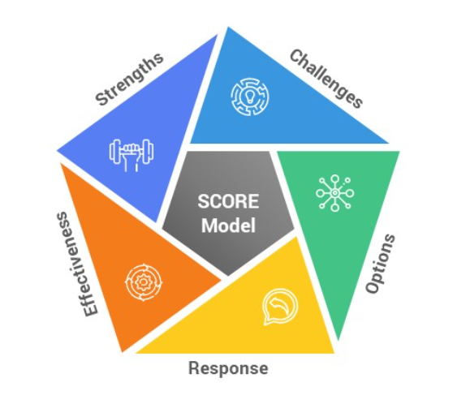
Figure 1: SCORE Model as Strategy Assessment (Neal, 2023)

SCORE model is useful when we want to promote a people-first company culture, and this strategy encourages teams to evaluate the institution’s strengths, challenges, opportunities, partnerships, and activities. It is similar to the SWOT analysis, but it also indicates how colleague and stakeholder interactions are progressing, as well as the effort that employees put in. This paper considers SCORE compared to SWOT because SWOT matrix environmental factors are oversimplified in some cases and the results may even be far from reality (Taherdoost & Madanchian, 2021).

The SCORE model is often used in corporate and business contexts. In the context of education in STEM, the SCORE model has high potential to empower certain parts in teaching. The SCORE analysis is clearly a significant tool for firms. Studying the applicability of ChatGPT in STEM topics is critical for various reasons. First, it enables academics and students to investigate how AI may improve learning and research processes. ChatGPT can provide personalized teaching, assist with data analysis, and even generate hypotheses based on a large body of scientific literature. Second, knowing ChatGPT's application in STEM contributes to the efficiency of scientific research. It can filter through vast datasets, spot trends, and recommend experimental designs, hastening the rate of discovery in domains including as biology, physics and engineering. Furthermore, studying ChatGPT in STEM topics increases understanding of AI's capabilities and limitations. It sparks debates about ethical implications, prejudice reduction, and the acceptable application of AI in scientific activities.

By incorporating a complete and methodical approach to business assessment, it assists decision-makers in making informed decisions. The emphasis on both internal and external elements offers a comprehensive awareness of the organization's current situation, as well as the opportunities and challenges that lie ahead. As a result, the SCORE analysis enables businesses to maximize on their strengths, handle difficulties, capture opportunities, and develop suitable actions to fulfil the organization's mission.
Strength on ChatGPT in STEM subject
ChatGPT is a machine learning model or system that uses deep learning methods to generate text in the virtual world (online) just like human thought in real time. Based on these characteristics and abilities, ChatGPT is able to provide many benefits to the field of education, in the context of STEM teaching and learning, ChatGPT helps teachers and students to achieve objectives in teaching and learning sessions more effectively. From the teacher's point of view, the use of ChatGPT in the right way and method can help teachers to plan teaching and learning sessions based on STEM more effectively (Valeri et al., 2025). ChatGPT can help teachers to suggest resources or materials that can be used before a teaching and learning session begins (Lo, 2023). In addition, teachers can use ChatGPT to get methods or ways to explain to students the complex concepts found in STEM subjects.

STEM is usually related to the lesson content that full of complex and technical concepts that are difficult for most students to understand. Through the use of ChatGPT students will have an easier time understanding a concept in STEM subjects because the response given by ChatGPT will be adjusted according to the student's level of understanding, in other words students can learn according to their own abilities and needs (Ab Hamid et al., 2023). In addition, students can use ChatGPT as a self-learning medium, students can ask ChatGPT at any time and get an immediate answer without depending on the class schedule or the teacher (Ma et al., 2024).

Through the use of ChatGPT, students can also cultivate interest in STEM subjects, this is because learning STEM subjects using ChatGPT will be more interesting through more interactive explanations through text simulations or design activities generated by ChatGPT based on prompts submitted by students. ChatGPT provides comprehensive support for students and teachers in STEM learning, starting from support for the teacher's routine work to guidance for students for independent learning that helps from various learning angles.

Challenges on ChatGPT Application in STEM Subject
The usefulness of ChatGPT cannot be denied, although ChatGPT offers various advantages in supporting STEM learning, we cannot ignore the challenges that exist from its use (Rasul et al., 2023). Among the main challenges of using ChatGPT in STEM learning is the over-reliance on ChatGPT (Darvishi et al., 2024), from the context of its use in school, students are likely to rely too much on ChatGPT to solve the questions and assignments given by the teacher without understanding the basic concepts that should be learned. This can cause a reduction in the student's ability to think critically, and indirectly reduce the student's ability to solve problems independently. In addition, ChatGPT is likely to cause confusion and doubt in terms of STEM learning content to teachers and students (Rasul et al. 2023), this is because ChatGPT provides explanations based on the data available in its database only, therefore the accuracy of the explanations given cannot be ensured. If teachers and students only accepting the ChatGPT explanation recklessly without making a review, confusion in terms of understanding a STEM concept is likely to occur.

Limitation to the access on technology is also one of the challenges of using ChatGPT in STEM learning from the aspect of its use. Not all students or schools have access to devices, the internet or the knowledge to use ChatGPT, especially rural schools. Because of this, the digital divide between urban and rural students will expand. Ethics is also one of the main challenges of using ChatGPT in STEM learning, students who use ChatGPT to find ideas or complete assignments are likely to just copy and plagiarize responses given by ChatGPT without making any effort themselves. This situation will prevent real learning and violate academic ethics.

Options on ChatGPT in STEM subject (ROS)
The use of ChatGPT in STEM learning opens up great opportunities to enrich students' learning experiences and improve teacher efficiency. However, each of these opportunities comes with certain challenges that require in-depth discussion to ensure that the use of ChatGPT can be utilized optimally without affecting the quality of learning. The ability of ChatGPT in helping students to support self-learning can be developed by studying and evaluating the extent to which ChatGPT helps improve students' understanding of STEM concepts through evaluation and research, strategies can be formulated to reduce students' dependence on ChatGPT.

ChatGPT contributes to the development of technological literacy in STEM learning, for example by using ChatGPT students will be exposed to Ai technology and indirectly prepare them to face the challenges of Industrial Revolution 4.0, but students may not fully master how ChatGPT works and use it irresponsibly which leads to problems ethics in the academic angle. Based on the issue, a special technology literacy module involving the ethics of using ChatGPT can be developed so that its use complies with proper ethics and can be integrated into STEM learning (Bai et al., 2023).

In terms of teachers, ChatGPT really helps teachers in the preparation of STEM-based teaching and learning. Teachers can generate various materials such as notes, quizzes or plan activities suitable for the implementation of STEM learning, but teachers may be faced with the accuracy of facts or information provided by ChatGPT. Therefore, a detailed study and evaluation of the accuracy and suitability of teaching materials produced by ChatGPT can be implemented to optimize the use of ChatGPT in supporting STEM-based learning. Every opportunity to implement ChatGPT in STEM has great potential but still requires further and detailed research to ensure that ChatGPT becomes an effective tool in STEM learning in schools.

Responses on ChatGPT in STEM Subject (ROS)
ChatGPT in STEM received many responses from the community such as parents, teachers, students, and the industry. Parents and teachers actually have a view that does not fully support ChatGPT in STEM because they focus more on the students' own efforts to generate ideas than with the help of AI. Parents and teachers appreciate if students can work on their own ability to solve a problem in STEM, instead of just expecting ChatGPT. As for students, ChatGPT is very popular because it makes it easier for them to complete assignments quickly. ChatGPT is often used to guide students in writing essays, explain a concept and suggest additional learning materials. Some rely too much on ChatGPT to the point of making them lazy to think about complex problems.

On the part of the industry, ChatGPT is very helpful in increasing productivity, many companies think that ChatGPT helps speed up work processes such as compiling reports, creating content, and writing professional emails. In addition, ChatGPT helps employees save time in completing tasks that are routine or shaped creative. However, there are concerns that the use of AI technology can replace human workers, especially in routine or technical jobs.

Effectiveness on ChatGPT in STEM Subject (ROS)
Effectiveness on grit will be cover on the five main aspect of efficient, reliable, elegant, appropriate and integrated. For efficiency, the ChatGPT in STEM is efficient because ChatGPT is able to convey complex concepts in a way that is easy to understand, at the same time helping students to understand the basics of Mathematics, Science, Technology and Engineering. For example, in the field of Mathematics, ChatGPT can help students explain important concepts such as Algebra, Calculus and Statistics in an easy to understand way. In Science, ChatGPT is able to explain the basic principles of Physics, Chemistry and Biology, making it a good reference source for students who want to understand complex concepts.

In addition, ChatGPT's ability to help with programming and data analysis makes it very useful for students and professionals in the fields of technology and engineering. ChatGPT is an effective tool to support learning and problem solving in STEM subjects. It can help students and professionals save time and improve understanding, but its use should be combined with human expertise to achieve more comprehensive and accurate results. For reliability, the ChatGPT in STEM is efficient because ChatGPT is able to provide consistent explanations and information based on data and knowledge that has been trained. ChatGPT is often used to answer math, science, technology, and engineering questions by providing clear and logical solution steps. In addition, ChatGPT helps students and professionals in making references or understanding complicated concepts (Liang et al., 2023).

Furthermore, ChatGPT is able to generate answers immediately regardless of the user's time and location. This ability ensures that it can be relied upon for tasks such as helping with programming, explaining scientific formulas, or suggesting systematic problem-solving methods. Therefore, users can rely on it to support their learning or daily work. However, although it is efficient in terms of reliability for basic and simple tasks, ChatGPT needs additional validation when applied to more complex STEM problems. This is because it depends on the data available, and it is possible to produce less accurate answers in certain situations. Its use with human expertise will further increase its effectiveness.

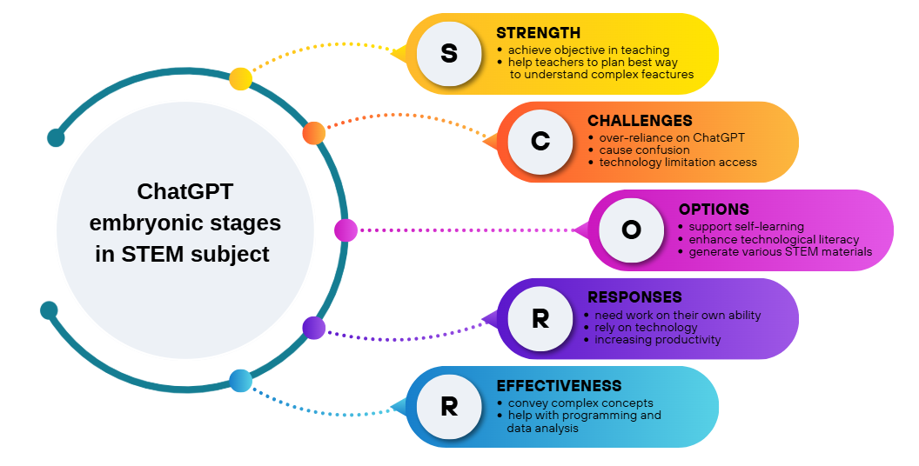
Figure 2: SCORE Framework on ChatGPT Embryonic

Stages in STEM Subject
Figure 2 is the SCORE model on ChatGPT embryonic stages in STEM subject that shows the aspect that needs to be empower by action taken from holistic approach. What we can learn from this framework is that the SCORE will help to monitor the development of ChatGPT in STEM future subject.

Conclusion
Overall, these results indicate that ChatGPT in STEM has a lot of potential not only in educational settings but also for business purposes. ChatGPT in STEM can be commercialized by integrating the stakeholders together in developing guidelines for intervention for the teaching and learning process. Due to practical constraints, this paper cannot provide a comprehensive review of SCORE. This study was only discussing positive action using the SCORE model. This can be improved by using any other model to get a variety of perspectives, such as SWOT, TOWS, NOISE, and SOAR. What is interesting in this concept paper is when the discussion explores ChatGPT embryonic stages in STEM subject which can be expanded in other subjects. This emphasis provides support for new AI-based teaching and learning styles. With the SCORE model, intervention opportunities will be more open when involving Complex Problem Solving (CPS) in STEM. By 2030, CPS can be a process for solving problems, big or small, using a sequence of specific steps within a given time frame. CPS is designed to develop student’s ability to use data to solve a STEM problem that is complicated. This finding has important implications for developing a new understanding of using the ChatGPT in STEM, especially for teachers and students. The teachers will use this information to improve their mindset and pedagogical practices, and the students will be encouraged to use the ChatGPT in a good manner in STEM subjects. Future studies on the current topic are therefore recommended. Further study could extend of doing research on the qualitative parts in exploring more on the factors that can threaten the ChatGPT in STEM, especially for those students with low ability in technology. This research will benefit community in identifying the potential of implementing ChatGPT in STEM.

Acknowledgment
We gratefully acknowledge financial support from Dana Penyelidikan SDG Fpend 2024 (GG-2024-044) by Universiti Kebangsaan Malaysia (UKM). We thank everyone involved in Writing Masterclass: Score Assessment Bootcamp that provided insight and expertise that greatly assisted the research. We thank all my friends in the Measurement and Evaluation course for assistance with constructive comments.

References
Ab Hamid, E. A. H., Maskur, H., & Abdul Mutalib, R. (2023). The Use of ChatGPT Applications in Learning: Impact on Understanding and Student Engagement in TVET Institutions. Malaysian Journal of Information and Communication Technology (MyJICT), 8(2), 78–87. https://doi.org/10.53840/myjict8-2-98
Al-Abdullatif, A. M., & Alsubaie, M. A. (2024). ChatGPT in Learning: Assessing Students’ Use Intentions through the Lens of Perceived Value and the Influence of AI Literacy. Behavioral Sciences, 14(9), 845. https://doi.org/10.3390/bs14090845
Bai, L., Liu, X., & Su, J. (2023). ChatGPT: The cognitive effects on learning and memory. Brain‐X, 1(3), 9. https://doi.org/10.1002/brx2.30
Darvishi, A., Khosravi, H., Sadiq, S., Gašević, D., & Siemens, G. (2024). Impact of AI assistance on student agency. Computers & Education, 210, 18. https://doi.org/10.1016/j.compedu.2023.104967
English, L. D. (2023). Ways of thinking in STEM-based problem solving. ZDM - Mathematics Education, 0123456789. https://doi.org/10.1007/s11858-023-01474-7
Liang, Y., Zou, D., Xie, H., & Wang, F. L. (2023). Exploring the potential of using ChatGPT in physics education. Smart Learning Environments, 10(1), 52. https://doi.org/10.1186/s40561-023-00273-7
Lo, C. K. (2023). What Is the Impact of ChatGPT on Education? A Rapid Review of the Literature. Education Sciences, 13(4), 15. https://doi.org/10.3390/educsci13040410
Ma, Q., Crosthwaite, P., Sun, D., & Zou, D. (2024). Exploring ChatGPT literacy in language education: A global perspective and comprehensive approach. Computers and Education: Artificial Intelligence, 7(July), 100278. https://doi.org/10.1016/j.caeai.2024.100278
Madunić, J., & Sovulj, M. (2024). Application of ChatGPT in Information Literacy Instructional Design. Publications, 12(11), 1–20. https://doi.org/10.3390/publications12020011
Rasul, T., Nair, S., Kalendra, D., Robin, M., Santini, F. de O., Ladeira, W. J., Sun, M., Day, I., Rather, R. A., & Heathcote, L. (2023). The role of ChatGPT in higher education: Benefits, challenges, and future research directions. Journal of Applied Learning & Teaching, 6(1), 17. https://doi.org/10.37074/jalt.2023.6.1.29
Valeri, F., Nilsson, P., & Cederqvist, A.-M. (2025). Exploring students’ experience of ChatGPT in STEM education. Computers and Education: Artificial Intelligence, 8, 12. https://doi.org/10.1016/j.caeai.2024.100360
Xu, W., & Ouyang, F. (2022). The application of AI technologies in STEM education: a systematic review from 2011 to 2021. International Journal of STEM Education, 9(1), 59. https://doi.org/10.1186/s40594-022-00377-5

